Java Servlet 3.0 and JSP 2.2
Lab Book




Document Revision History

Date | Revision No. | Author | Summary of Changes
May 2015 | 4.0 | Yukti A Valecha | Revamped from Servlets 2.5 to Servlets 3.0
May 2016 | 4.1 | Yukti A Valecha /Anjulata | Revamped as per revised course contents
Feb 2018 | 4.2 | Bharati Thorat | Revamped as per revised course contents

Table of Contents
Document Revision History 2
Table of Contents 3
Getting Started 4
Overview 4
Setup Checklist for Servlets 3.0 4
Instructions 4
Lab 1. Servlet Basics 5
Lab 2. Request Objects 6
Lab 3. JSP Basics 7
3.1: JSP Scripting Elements and Method Declarations 7
3.2 : JSP Directive 8
Lab 4 : JSP Actions 9
4.1: Integrating Servlet, JSP (2 – Model-View-Controller pattern) 9
Lab 5. JSP Standard Tags Libraries (JSTL) 18
Lab 6 .Session Management 19

Getting Started

Overview
This lab book is a guided tour for learning Servlets 3.0 and JSP 2.2. It comprises scenario based applications and ‘To Do’ assignments. Flow diagrams and screen snap shots are provided where necessary.

Setup Checklist for Servlets 3.0
Here is what is expected on your machine in order for the lab to work.
Minimum System Requirements
- Intel Pentium 90 or higher (P166 recommended)
- Microsoft Windows 95, 98, or NT 4.0, 2k, XP.
- Memory: 32MB of RAM (64MB or more recommended)
- Java SE version 8
- Internet Explorer 6.0 or higher
- Connectivity to Oracle database
- WildFly server Version 8.1.0

Please ensure that the following is done:
- STS 3.9.2 RELEASE

Instructions

- All lab assignments should refer coding standards.
- Create a directory by your name in drive <drive>. In this directory, create a subdirectory servlet_assgn. For each lab exercise create a directory as lab <lab number>.
You may also look up the on-line help provided in JEE documentation

- Servlet Basics

Goals | - Understanding Servlet Basics and Invocation
Time | 0.5 Hour

  - Create a Servlet program that will print the system date and time.

Note: The Servlet should be invoked in the following ways:
- On clicking of Hyper Link in html page
- On clicking of button in html page
- On typing the servlet URL pattern directly in Address bar of browser

- Request Objects

Goals | - Understanding the request Object
Time | 0.5 Hours

2.1: Design a login Page accepting username and password in HTML. The credentials need to be authenticated in Servlet.
The credentials could be validated by using hard coded values for username and password.
If user is valid then display HTML page as “Success” and display HTML page as “Failure” if user is invalid.

Note:
- The control can be forwarded to HTML pages using request.getRequestDispatcher (String URLPattern) method.

Refer below figure for HTML Login Page:

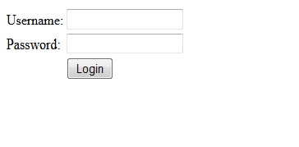
Figure 1 : User Login Page

- JSP Basics

Goals | - Create simple JSP programs.
Time | 1.5 hrs.

3.1: JSP Scripting Elements and Method Declarations
Problem:

Create a JSP page to accept username and password from user as shown in figure 2. Authenticate the user using JSP scriptlets and display appropriate success or error message on a new page.

Authentication should be done using a java method that is declared in the JSP page.

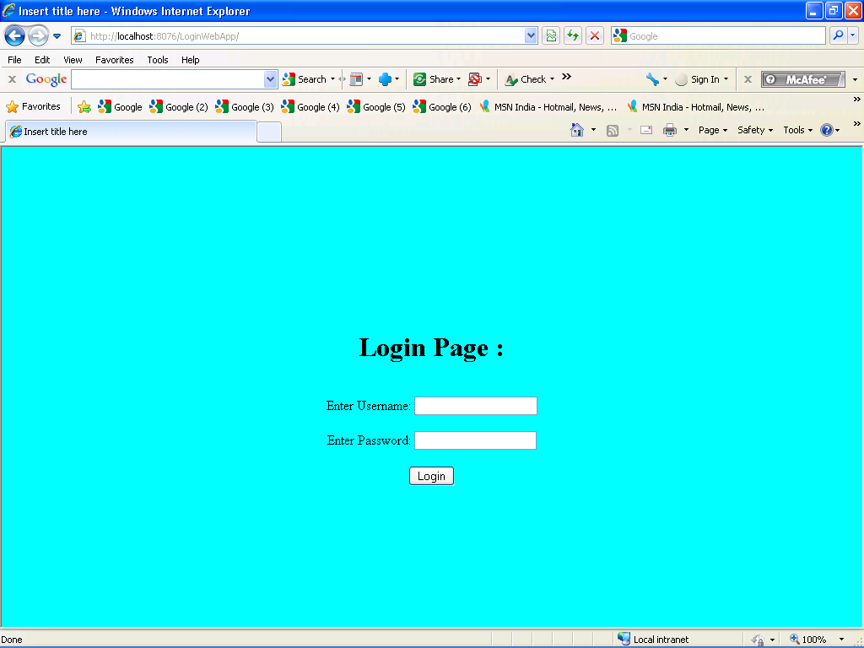

Figure 2 : Login.jsp

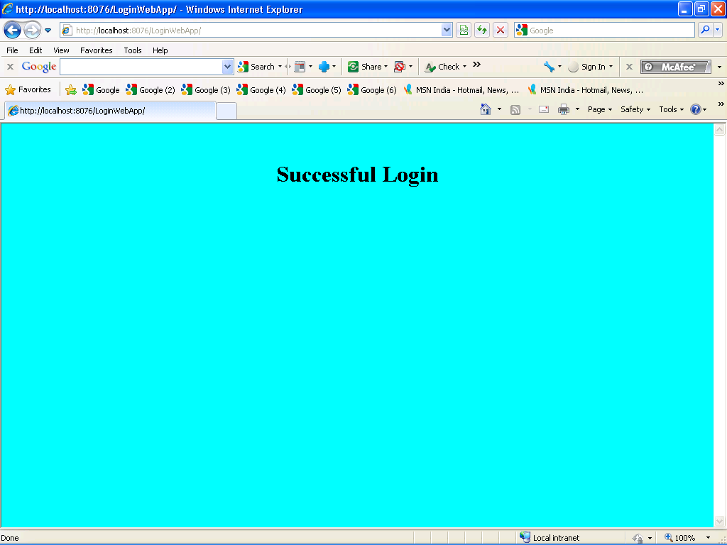

Figure 3 : Success.jsp

3.2 : JSP Directive
Problem:

Modify the assignment 3.1. Create Error.jsp. Include a common Header page to all these pages with the help of include directive.

In the Login.jsp page, set errorPage attribute as “Error.jsp” and in Error.jsp page set isErrorPage attribute as “true”.

In the Login.jsp page authenticate the user as per the instructions given in lab 3.1.

If authentication fails then throw a LoginException from scriptlet code with a user defined exception message..

Lab 4 : JSP Actions

Goals | - Integrating JSP and Servlets using forward action
Time | 2 hours

4.1: Integrating Servlet, JSP (2 – Model-View-Controller pattern)
Develop an online E Bill application that allows the user to accept readings for a consumer and calculate bill amount and persist the details. The work flow of the application is shown in the figure 4 given below.
Database
Index.html
(View)

EBillController
(Controller)

Error.jsp
(View)

EBillException

Show_ConsumerList.jsp (View)

Service Layer
DAO Layer
Show_Bills.jsp (View)

Search_Consumer.jsp (View)

Bill_Info.jsp
(View)

ConsumerDTO

BillDTO

Figure 4 : Implementing MVC pattern

Solution:
Follow the MVC (Model View Controller) approach wherein a controller servlet will intercept all the requests and select the appropriate model to process the request. After the processing is complete, the controller can forward the request to the appropriate JSP (view) for presentation.
Spec1: Create the following database tables in Oracle
Table Script
CREATE TABLE Consumers(
consumer_num NUMBER(6) PRIMARY KEY,
consumer_name VARCHAR2(20) NOT NULL,
address VARCHAR2(30)
);

INSERT INTO Consumers VALUES(100001,'Sumeet','Shivaji Nagar, Pune');
INSERT INTO Consumers VALUES(100002,'Meenal','M G Colony Panvel, Mumbai');

INSERT INTO Consumers VALUES(100003,'Neeraj','Whitefield, Bangalore');
INSERT INTO Consumers VALUES(100004,'Arul','Karapakkam, Chennai');

CREATE TABLE BillDetails(
bill_num NUMBER(6) PRIMARY KEY,
consumer_num NUMBER(6) REFERENCES Consumers(consumer_num),
cur_reading NUMBER(5,2),
unitConsumed NUMBER(5,2),
netAmount NUMBER(5,2),
bill_date DATE DEFAULT SYSDATE);

CREATE SEQUENCE seq_bill_num START WITH 100;

Spec2: Create the view index.html as shown in following figure 5.
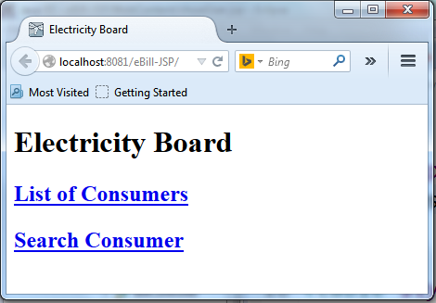
Figure 5 : index.html
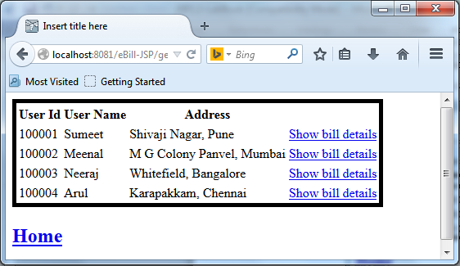
Figure 6 : Show_ConsumerList.jsp

And display page as shown in the figure 7 for second link from index page:

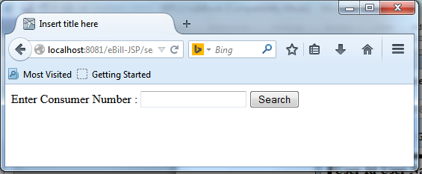
Figure 7 : Search_Consumer.jsp
Spec 4: After clicking on the Search button for a valid user id in Search_Consumer page shown in the figure 8 should be displayed in output.

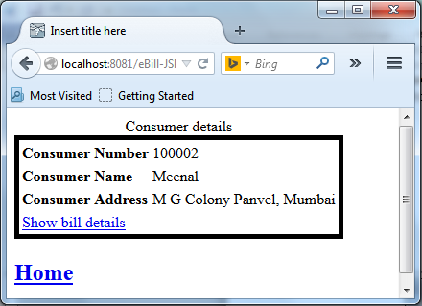
Figure 8 : Show_Consumer.jsp

Spec 5: After clicking on the Show bill details link it will display the bill details for that consumer as below in the figure 9. The below page should be displayed when user clicks on the Show bill details link in the Show_ConsumerList page.

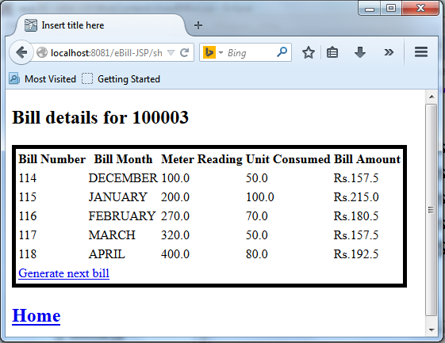

Figure 9:Show_Bills.jsp
Spec6: After clicking on Generate nextbill link following form as shown in figure 10 should be displayed to accept meter readings for that consumer.
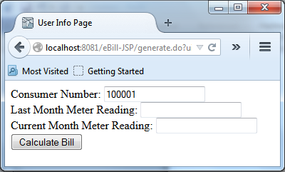
Figure 10:User_Info.jsp

Spec7: After clicking on the Calculate BillButton ,Bill must be generated.

Refer below calculations:

Units consumed = (Current month meter reading)- (Last month meter reading)
Net Amount = Unit consumed * 1.15 + Fixed Charge

Assume Fixed Charge is always Rs.100.

After calculating the electricity bill, bill details needs to be inserted into the database table billdetails.

Note:
- Bill_id should be auto generated by sequence.
- Bill_date should be current date.

Insert the details in the database and display the bill as shown in the following figure 11

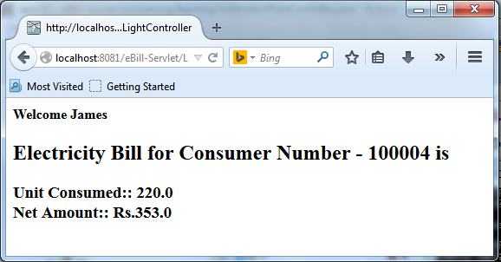
Figure 11 : Bill_Info.jsp

Spec 8: In case of error, user defined error message should be displayed as shown in figure 12.
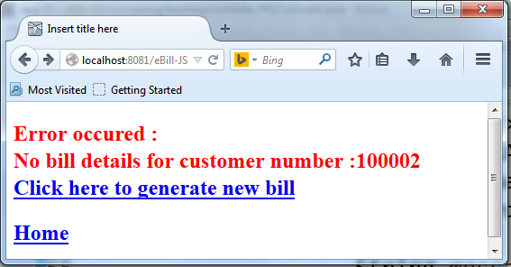

Figure 12 : Error.jsp

Lab 5. JSP Standard Tags Libraries (JSTL)

Goals | - Using core Tag Libraries
Time | 0.5 hrs
Pre-requisite | XML Basics and Java

5.1 Modify Electricity Bill application which was developed in previous lab by developing JSP pages using appropriate JSTL tags and Lambda Expression, replacing all the scripting elements.

Lab 6 .Session Management

Goals | - Understanding Session Management
Time | 1 Hours

6.1. Modify Lab 4.1 using session tracking at appropriate places.

Table of Figures

Figure 1 : User Login Page 6

